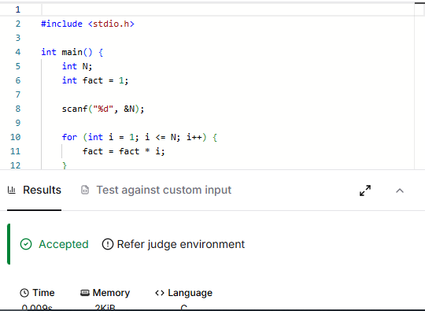

CODE –
#include <stdio.h>

int main() {
int N;
int fact = 1;

scanf("%d", &N);

for (int i = 1; i <= N; i++) {
fact = fact * i;
}

LINK –
https://www.hackerearth.com/practice/basic-programming/input-output/basics-of-input-output/practice-problems/algorithm/find-factorial/

